Name: | (Type in your first name, middle initial, and last name here)
Date: | (Type in day, and date here)

MS Word Exercise 1
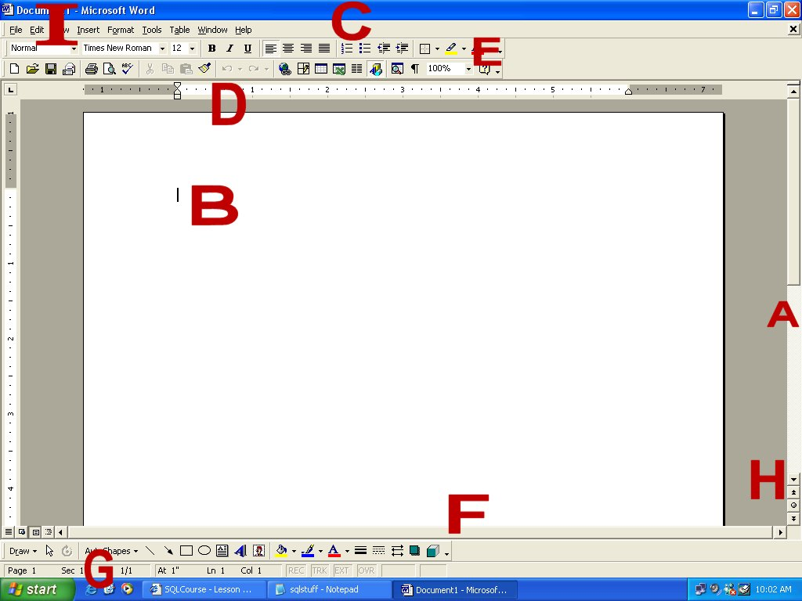
Figure 1.1 – The MS Word Blank Document
Type the correct term to the right of each letter, describing the objects in the MS Word window as shown in Figure 1.1
A | Vertical Scroll Bar
B
C
D
E
F
G
H
I
List of terms: Vertical scroll bar, Horizontal scroll bar, Status bar, Ruler, Title bar, Insertion point, Document title, Scroll arrow, toolbar
List the name of every (19) toolbar and the name of one button on each toolbar
Toolbar |  | Toolbar Name | Name of a Button
1
2
3
4
5
6
7
8
9
10
11
12
13
14
15
16
17
18
19
20
Do the following tasks
Make this line of text font “Arial”
Make this line of text font size “24”
Make this line of text “bold”
Make this line of text “Italics”
Make this line of text “Underline”
Make this line of text “Left Justified”
Make this line of text “Center Justified”
Make this line of text “Right Justified”
Make this line of text “Justified”, making it stretch from the left margin to the right margin
Put a number in the front of this line of text
Put a bullet in the front of this line of text
Decrease the indent on this line of text
Increase the indent on this line of text
Place a border around this line of text
Highlight this line of text
Change the color of this line of text to “red”
Center the graphic of the two graduates over this text
Insert a clip art graphic of a computer mouse
Correct the spelling for this paragraph.
Dear MS Word Student,

Welcone to my clas. I have been teeching at Technogiy Education Colege for many years. I am lookin forward to teechin ya how to use a wood processing program.

Sincerelly ,

Your MS Wood Instrucor

Thank you for completing this exercise

